Пупов Нікіта Варіант 19

|  |  |  |
| --- | --- | --- |
| $$x_{1}^{S}$$ | $$x_{2}^{S}$$ | $$Q^{S+1}$$ |
| 0 | 0 | 0 |
| 0 | 1 | $${\overline{Q}}^{S}$$ |
| 1 | 0 | 1 |
| 1 | 1 | 0 |

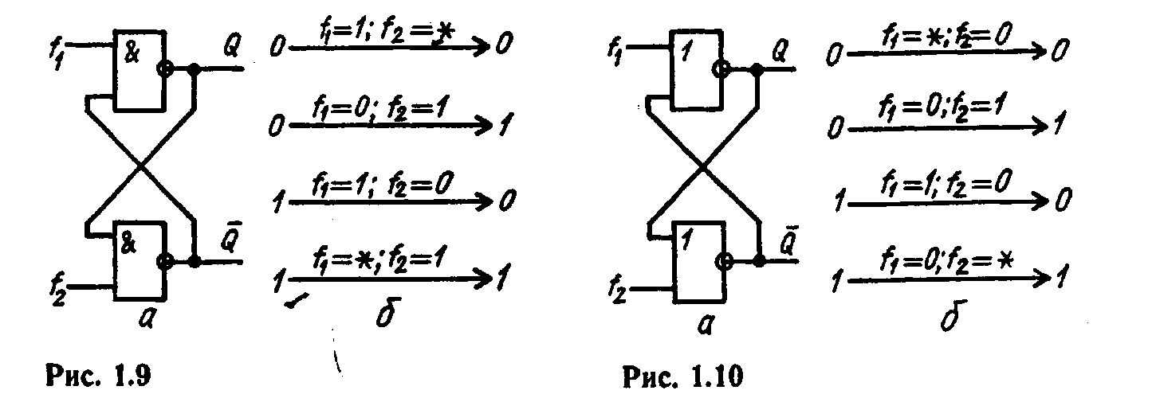

|  |  |  |  |  |  |  |
| --- | --- | --- | --- | --- | --- | --- |
| *CS* | *JS* | *KS* | *QS* | *QS*+1 | *f*1 | *f*2 |
| 0 | 0 | 0 | 0 | 0 | 1 | * |
| 0 | 0 | 0 | 1 | 1 | * | 1 |
| 0 | 0 | 1 | 0 | 0 | 1 | * |
| 0 | 0 | 1 | 1 | 1 | * | 1 |
| 0 | 1 | 0 | 0 | 0 | 1 | * |
| 0 | 1 | 0 | 1 | 1 | * | 1 |
| 0 | 1 | 1 | 0 | 0 | 1 | * |
| 0 | 1 | 1 | 1 | 1 | * | 1 |
| 1 | 0 | 0 | 0 | 0 | 1 | * |
| 1 | 0 | 0 | 1 | 0 | 1 | 0 |
| 1 | 0 | 1 | 0 | 1 | 0 | 1 |
| 1 | 0 | 1 | 1 | 0 | 1 | 0 |
| 1 | 1 | 0 | 0 | 1 | 0 | 1 |
| 1 | 1 | 0 | 1 | 1 | * | 1 |
| 1 | 1 | 1 | 0 | 0 | 1 | * |
| 1 | 1 | 1 | 1 | 0 | 1 | 0 |

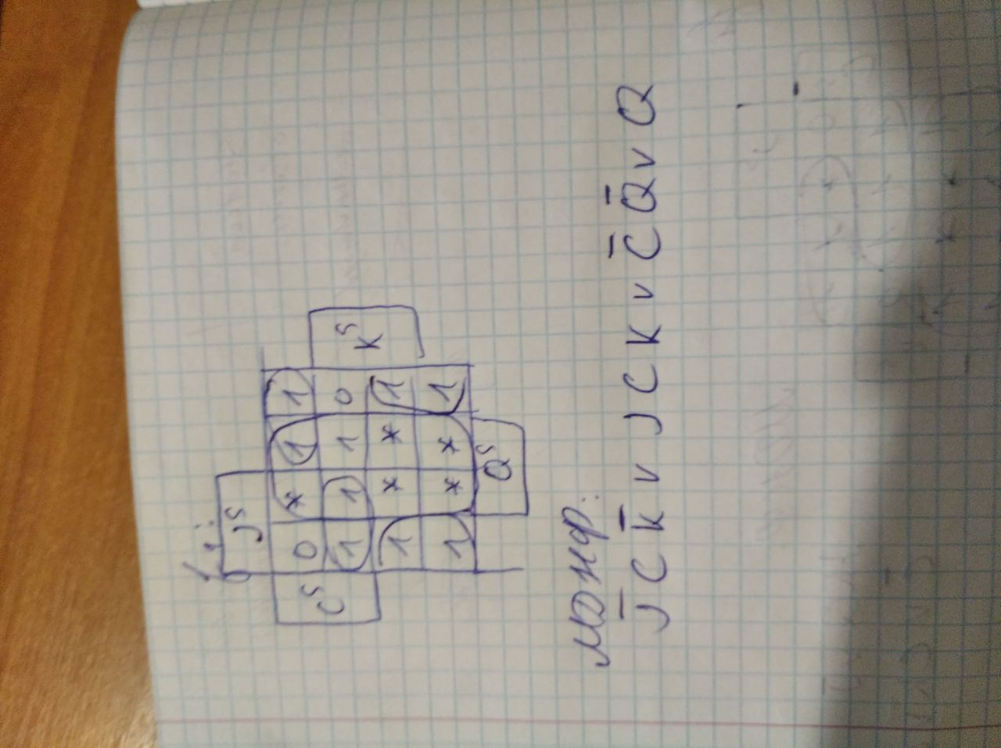

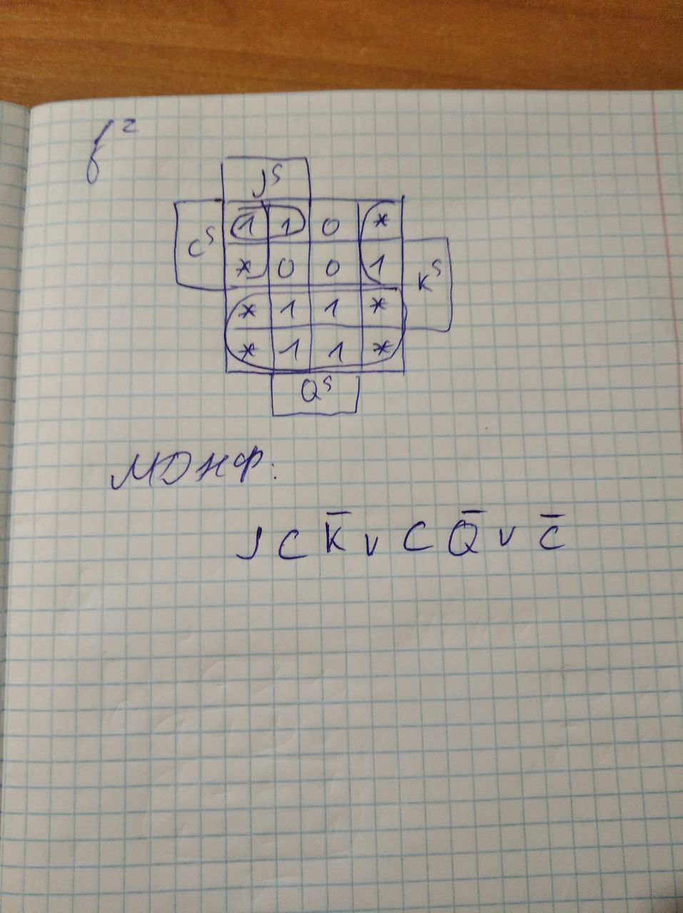

Приводимо ці функції до виду, зручному в представленні І-НІ

